**Assignment 5 Documentation**

**Matthew Melendez**

**SUNY University at Albany**

**ICSI 412 – Operating Systems**

**System Documentation**

High-level Data Flow Diagram

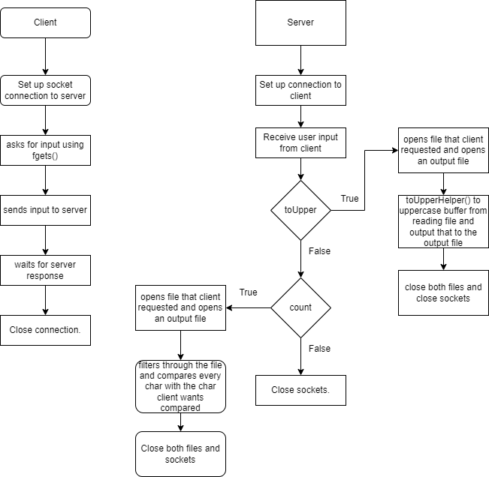

List/Routines and Their Brief Description

* toUpperHelper(char *string)
  + This function is responsible for helping out toUpper command get everything in the file uppercased.

Implementation

To help implement this assignment, I used the code that was provided to me through the assignment and used online resources such as geekforgeeks to help understand my implementation better.

**Test Documentation**

How I Tested My Program

The way that I tested my program was simple. I provide one test case on each function for the client. These test cases helped identify segmentation faults that I had with the code.

List of Test Sets

* toUpper intext.txt

This test case worked well as it the server was able to get the command from the client side and was able to uppercase the whole file into a new file.

* count s intext.txt

This test case worked well too. The client sent the command with the arguments to the server and the server was able to digest the command and properly count how many “s” there were.

**User Documentation**

How To Run My Program

To run the program, you need to run the server first by inputting into the terminal the following command: ./server 54555. If you try to run another instance of the server, you need to change the port number.

Following that, you need to run the client by inputting this following command in a different computer or terminal: ./client 127.0.0.1 54555. The client side will ask you to input one of the following commands, toUpper or count.

Parameters

To use toUpper, you input into the terminal on the client side: toUpper <filename>. For example, toUpper intext.txt.

To use count, you input into the terminal on the client side: count <char> <filename>. For example, count s intext.txt.